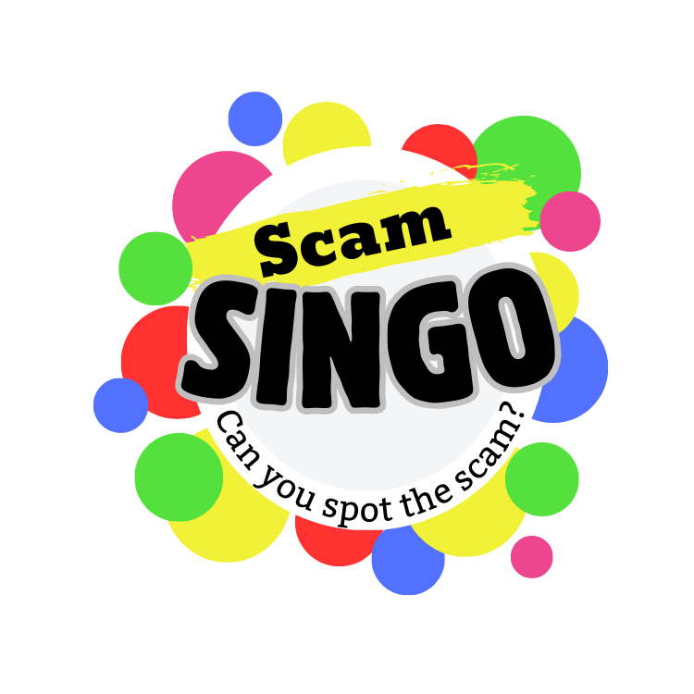**Join us for**

**FREE**

**Prizes!**

**SINGO is Bingo with music!**

Join us as we listen to the Golden Oldies and play a fun game of SINGO. Learn how the songs can help protect you and your loved ones from scams!

***Insert extra event info – Remove if not needed***

Date: _______________________________________________

Time: _______________________________________________

Location: ____________________________________________

RSVP: _______________________________________________